Student Names: 4384 muhammad naveed
Instructor: Muhammad Ejaz

Lab Task No 4
- WAP to print the squares of numbers from 1 to 10 using a for loop.

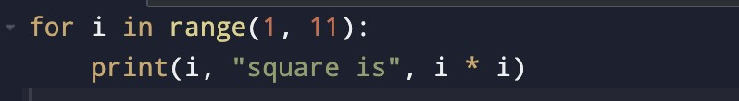

Output :
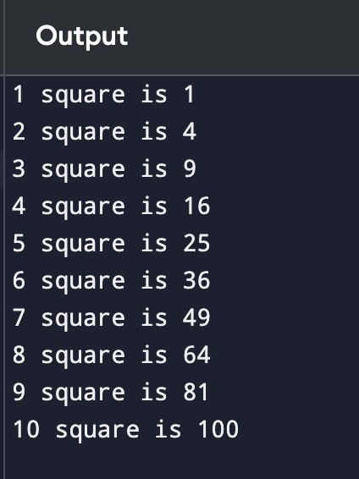
- WAP to iterate through a string and count how many vowels it contains.
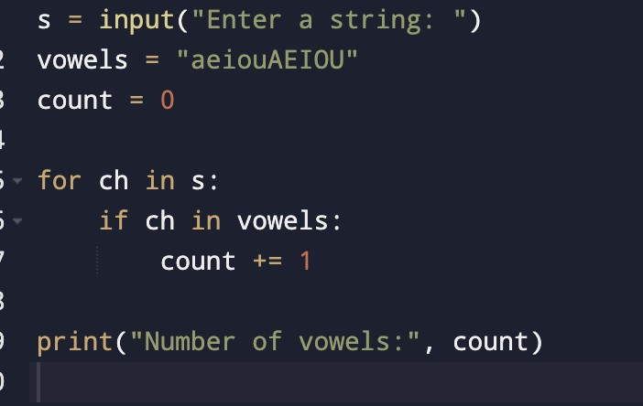
Output :
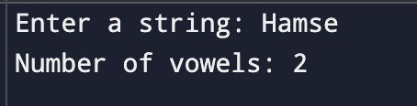
- Given a list of marks, print only the marks greater than 50 using a for loop.
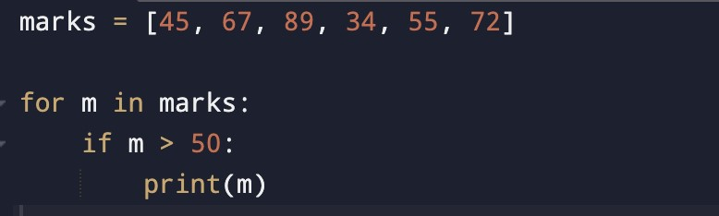
Output :
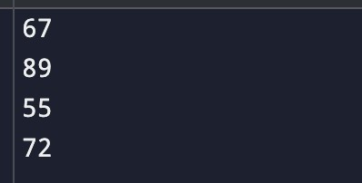
- WAP to print multiplication table of a number entered by the user
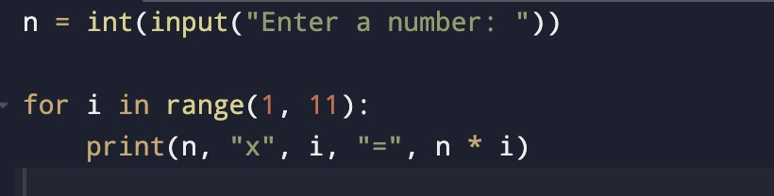
Output :
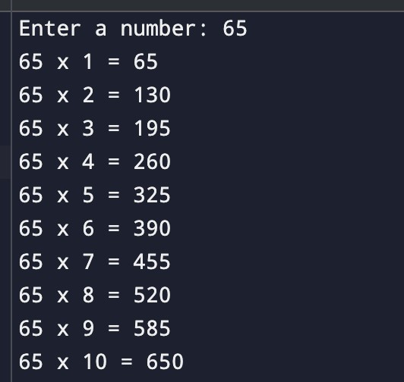
- WAP using while loop to print all odd numbers between 1 and 20.
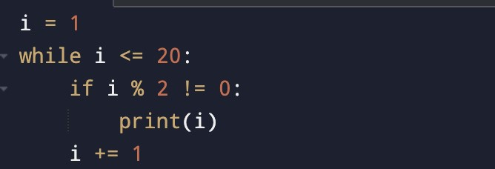
Output :
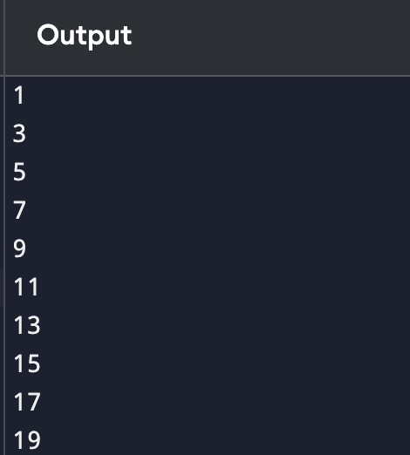
- WAP to repeatedly ask for a password until the user enters the correct one.
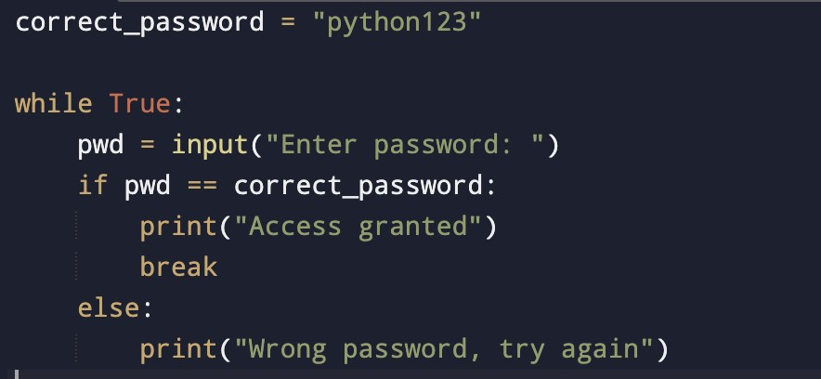
Output :
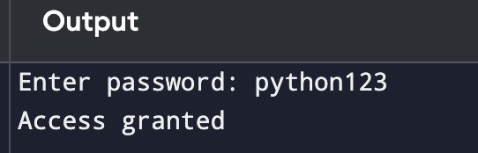
- Keep taking input from the user until they type “stop”.
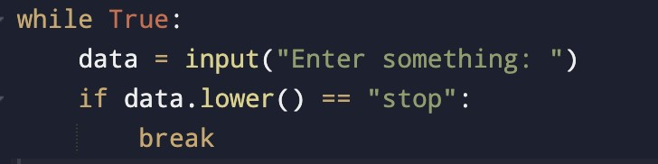
Output :
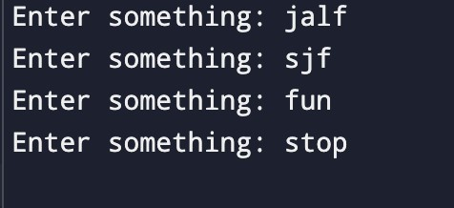
- Calculate the sum of numbers from 1 to n.
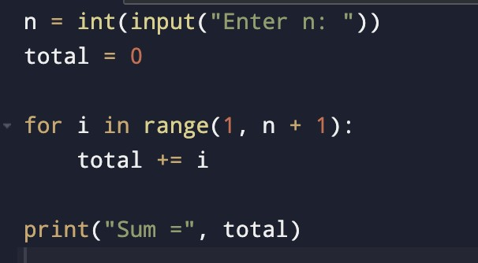
Output :
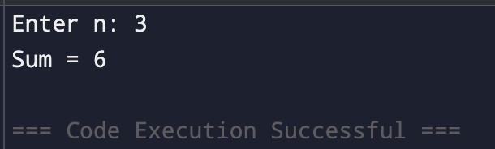
- Find the largest number in a list without using max().
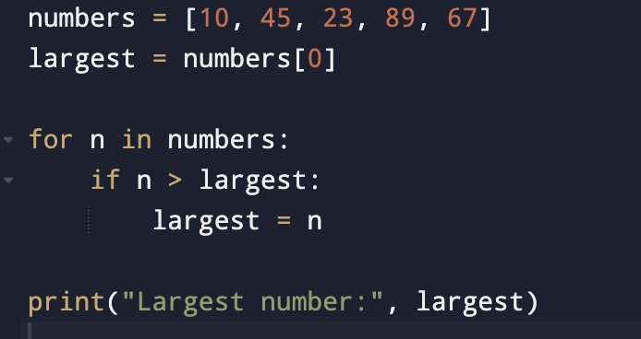
Output :
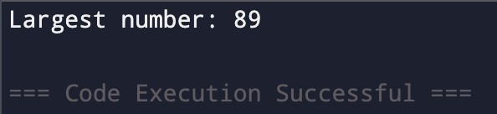
- Print all elements of a list using a for loop.
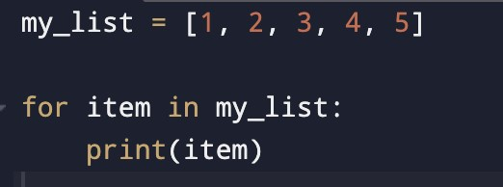
Output :
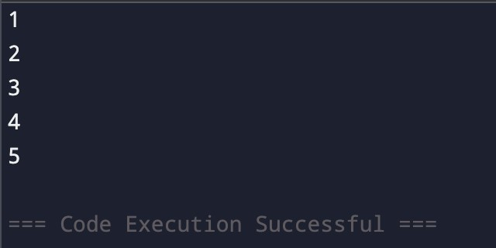
- Keep reading numbers until the user enters a negative number; then print the average
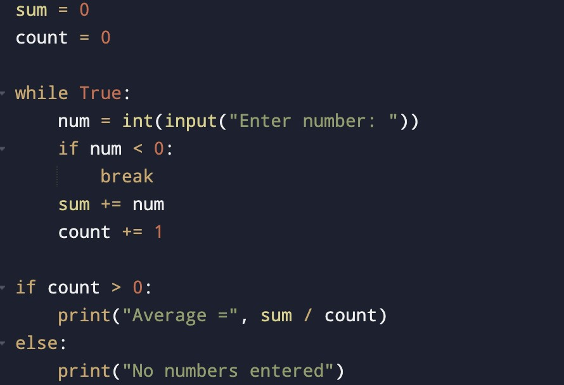
Output :
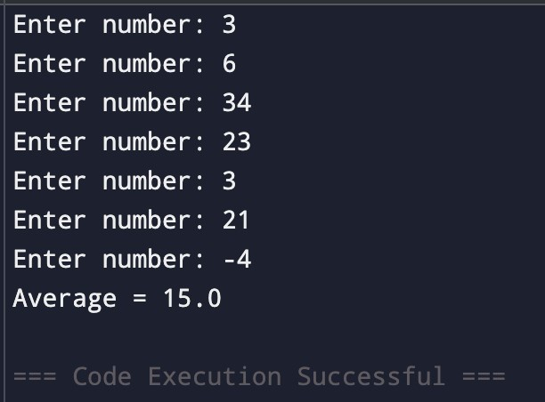
- Check if a number is a palindrome using a while loop.
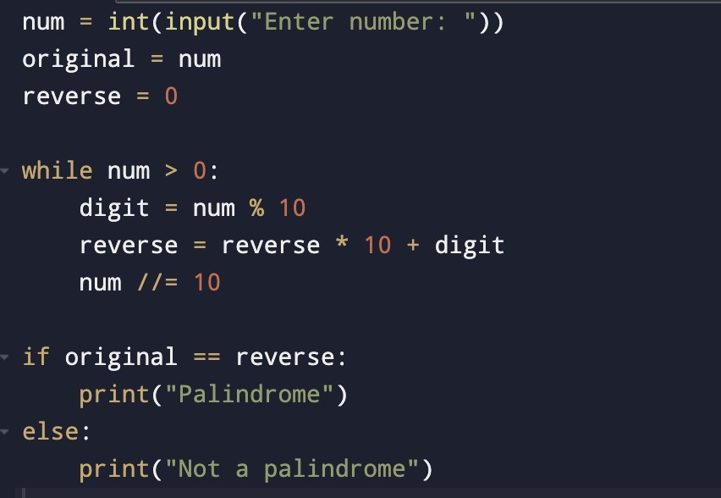
Output :
